Nigerian Naira Risk-free spot rate curve for April 2024

This document sets out the specifics of the methodology used for the calculation of the risk-free spot rate curve as at 30 April 2024.

During the month, the DMO issuances were as shown in the table below

Bond Name | Subscription Amount (N’bn) | Allocated Amount (N’bn) | Marginal rates
19.30% APR 2029 | 239.54 | 79.92 | 19.30
18.50% FEB 2031 | 129.72 | 85.05 | 19.75
19.00% FEB 2034 | 550.83 | 461.85 | 20.00
TOTAL | 920.09 | 626.81 | 19.78

In March, the DMO issued 1 new bond with a duration of 5 years (i.e. 19.30% April 2029 bond) and re-opened 2 other bonds i.e. 18.50% FEB 2031 and 19.00% Feb 2034 which were first issued in February 2024. The total allocated amount to bonds of N627 billion in April is broadly similar to that allocated in March of N609 billion.

This is a continuation of CBN’s attempt to mop up excess liquidity in the system in order to stabilise the naira and offer more attractive returns to investors. The closing average marginal yield for the April auction was c. 41bps lower than the closing average for March 2024.

The new bond issued in April 2024 as well as all bonds issued since February 2024 have not been included in the construction of the yield curve. This is currently under review with a view to see which ones should be included next month.

Similar to last month, the Smith Wilson Model did compute without any manipulation to the yields of the longest duration bonds.

The table below sets out the bonds available, their features and what have been included in our calculation.

Description | Issue Date | Coupon (%) | Outstanding Value (₦’bn) | Maturity Date | TTM (Yrs) | Yield (%) | Closing Price | Liquid Bonds | Included in Calc
^13.53 23-MAR-2025 | 23-Mar-18 | 13.53 | 562.45 | 23-Mar-25 | 0.90 | 18.96 | 95.66 | Yes | No
^12.50 22-JAN-2026 | 22-Jan-16 | 12.50 | 1199.74 | 22-Jan-26 | 1.73 | 18.07 | 91.97 | Yes | Yes
^21.00 20-MAR-2026 | 20-Mar-24 | 21.00 | 700.00 | 20-Mar-26 | 1.89 | 18.09 | 104.42 | Yes | No
^16.2884 17-MAR-2027 | 17-Mar-17 | 16.29 | 1035.03 | 17-Mar-27 | 2.88 | 18.46 | 95.25 | Yes | Yes
^19.94 20-MAR-2027 | 20-Mar-24 | 19.94 | 1251.93 | 20-Mar-27 | 2.89 | 19.45 | 100.96 | Yes | No
^13.98 23-FEB-2028 | 23-Feb-18 | 13.98 | 1625.52 | 23-Feb-28 | 3.81 | 18.95 | 86.84 | Yes | Yes
^21.00 20-MAR-2028 | 20-Mar-24 | 21.00 | 558.24 | 20-Mar-28 | 3.89 | 18.93 | 105.43 | Yes | No
15.00 28-NOV-2028 | 28-Nov-08 | 15.00 | 75.00 | 28-Nov-28 | 4.58 | 19.07 | 87.89 | No | No
19.30 17-APR-2029 | 17-Apr-24 | 19.30 | 79.92 | 17-Apr-29 | 4.96 | 19.10 | 100.60 | No | No
^14.55 26-APR-2029 | 26-Apr-19 | 15.49 | 1040.31 | 26-Apr-29 | 4.99 | 19.14 | 85.63 | Yes | Yes
12.49 22-MAY-2029 | 22-May-09 | 12.49 | 150.00 | 22-May-29 | 5.06 | 19.16 | 78.94 | No | No
8.50 20-NOV-2029 | 20-Nov-09 | 8.50 | 200.00 | 20-Nov-29 | 5.56 | 19.29 | 64.16 | No | No
10.00 23-JUL-2030 | 23-Jul-10 | 10.00 | 591.57 | 23-Jul-30 | 6.23 | 19.45 | 66.63 | No | Yes
^18.50 21-FEB-2031 | 21-Feb-24 | 18.50 | 1006.46 | 21-Feb-31 | 6.81 | 19.60 | 95.86 | Yes | No
^12.50 27-APR-2032 | 27-Apr-22 | 12.50 | 848.11 | 27-Apr-32 | 7.99 | 19.66 | 71.72 | Yes | Yes
14.70 21-JUN-2033 | 21-Jun-23 | 14.70 | 331.91 | 21-Jun-33 | 9.14 | 19.60 | 79.44 | No | No
^19.00 21-FEB-2034 | 21-Feb-24 | 19.00 | 1492.28 | 21-Feb-34 | 9.81 | 19.57 | 97.43 | Yes | No
^12.1493 18-JUL-2034 | 18-Jul-14 | 12.15 | 1075.92 | 18-Jul-34 | 10.21 | 19.07 | 69.28 | Yes | Yes
^12.50 27-MAR-2035 | 27-Mar-20 | 12.50 | 972.04 | 27-Mar-35 | 10.90 | 19.03 | 70.38 | Yes | No
^12.40 18-MAR-2036 | 18-Mar-16 | 12.40 | 926.14 | 18-Mar-36 | 11.88 | 18.97 | 69.33 | Yes | Yes
^16.2499 18-APR-2037 | 18-Apr-17 | 16.25 | 1796.66 | 18-Apr-37 | 12.97 | 18.92 | 87.21 | Yes | Yes
^15.45 21-JUN-2038 | 21-Jun-23 | 15.45 | 691.34 | 21-Jun-38 | 14.14 | 18.10 | 86.55 | Yes | No
^13.00 21-JAN-2042 | 21-Jan-22 | 13.00 | 1393.75 | 21-Jan-42 | 17.73 | 18.69 | 70.77 | Yes | Yes
9.80 24-JUL-2045 | 24-Jul-20 | 9.80 | 437.46 | 24-Jul-45 | 21.23 | 18.65 | 53.57 | No | Yes
^14.80 26-APR-2049 | 26-Apr-19 | 14.80 | 1765.67 | 26-Apr-49 | 24.99 | 18.61 | 79.77 | Yes | Yes
^12.98 27-MAR-2050 | 27-Mar-20 | 12.98 | 1595.41 | 27-Mar-50 | 25.90 | 18.33 | 71.09 | Yes | Yes
^15.70 21-JUN-2053 | 21-Jun-23 | 15.70 | 1770.16 | 21-Jun-53 | 29.14 | 18.45 | 85.10 | Yes | Yes

Overall, the yields in April are broadly lower at the short end of the curve and broadly similar at the middle of the curve.

For the shorter end of the yield curve, Treasury bill market was considered. The following Treasury bill instruments are available

DTM | Maturity | Closing Rate (%) | Yield (%) | Closing Price | Outstanding Value (₦’bn) | Liquid T'bills | Included in Calcs
9 | 9-May-24 | 25.00 | 25.16 | 99.39 | 179.36 | Yes | No
23 | 23-May-24 | 21.00 | 21.28 | 98.68 | 508.98 | No | No
37 | 6-Jun-24 | 23.87 | 24.46 | 97.59 | 221.13 | Yes | No
58 | 27-Jun-24 | 23.65 | 24.57 | 96.25 | 228.71 | No | No
72 | 11-Jul-24 | 23.50 | 24.64 | 95.38 | 166.11 | Yes | No
86 | 25-Jul-24 | 18.05 | 18.85 | 95.76 | 277.96 | No | No
100 | 8-Aug-24 | 18.15 | 19.10 | 95.04 | 199.50 | Yes | No
114 | 22-Aug-24 | 19.00 | 20.20 | 94.08 | 349.29 | No | No
128 | 5-Sep-24 | 18.36 | 19.62 | 93.58 | 213.71 | Yes | No
135 | 12-Sep-24 | 18.41 | 19.76 | 93.21 | 155.10 | No | No
149 | 26-Sep-24 | 18.52 | 20.03 | 92.46 | 199.39 | No | No
177 | 24-Oct-24 | 18.73 | 20.61 | 90.94 | 361.53 | Yes | No
191 | 7-Nov-24 | 19.00 | 21.10 | 90.08 | 487.24 | Yes | No
205 | 21-Nov-24 | 19.00 | 21.27 | 89.36 | 540.45 | No | No
219 | 5-Dec-24 | 18.05 | 20.24 | 89.20 | 563.12 | Yes | No
226 | 12-Dec-24 | 19.11 | 21.68 | 88.20 | 256.51 | No | No
240 | 26-Dec-24 | 19.22 | 22.00 | 87.40 | 268.74 | No | No
268 | 23-Jan-25 | 19.43 | 22.67 | 85.73 | 217.53 | Yes | No
282 | 6-Feb-25 | 19.54 | 23.02 | 84.90 | 908.75 | Yes | No
296 | 20-Feb-25 | 20.00 | 23.87 | 83.78 | 1192.09 | No | No
310 | 6-Mar-25 | 21.00 | 25.56 | 82.16 | 1292.71 | Yes | Yes
317 | 13-Mar-25 | 20.20 | 24.50 | 82.46 | 150.85 | No | No
331 | 27-Mar-25 | 21.35 | 26.48 | 80.64 | 1582.05 | No | No

It is noted that at the end of April 2024, the yields on Treasury bills were higher than that observed at the end of March 2024 at all maturities especially at the short end. The outstanding value of the Treasury Bills market at the end of April 2024 was N10.5 trillion which compares with March 2024 atN7.7 trillion, February 2024 at N7.1 trillion and January 2024 which was c. N6.2 trillion.

In April, the interpolated yields are broadly similar to those in March except at the short end. The year 1 yields in April are significantly higher than March but up to year 10, the rates in April are lower than those observed in March.

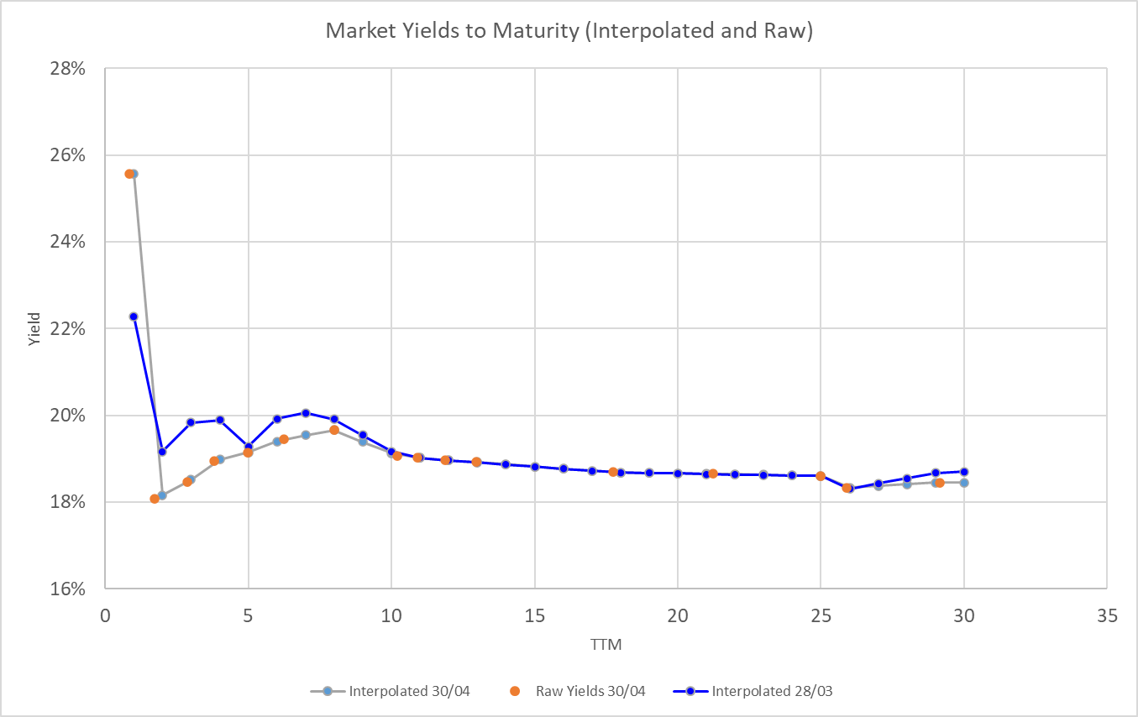

For the Smith Wilson Model the following inputs have been used
- The Last Liquid point of 30 years;
- The Ultimate Forward Rate of 18.45%; and
- The minimum alpha of 3.24
Further details of the overall methodology document can be found at IFRS 17 Discount Rate Methodology and details of earlier months are available at News – NAS (actuaries.org.ng).

The following are graphs of the risk-free spot rates curves for
- April 2024
- March 2024 and April 2024
- December 2023, March 2024 and April 2024

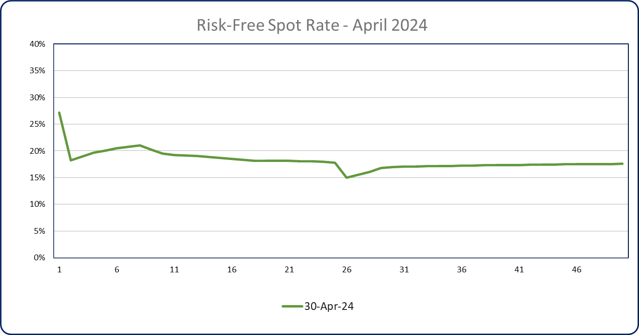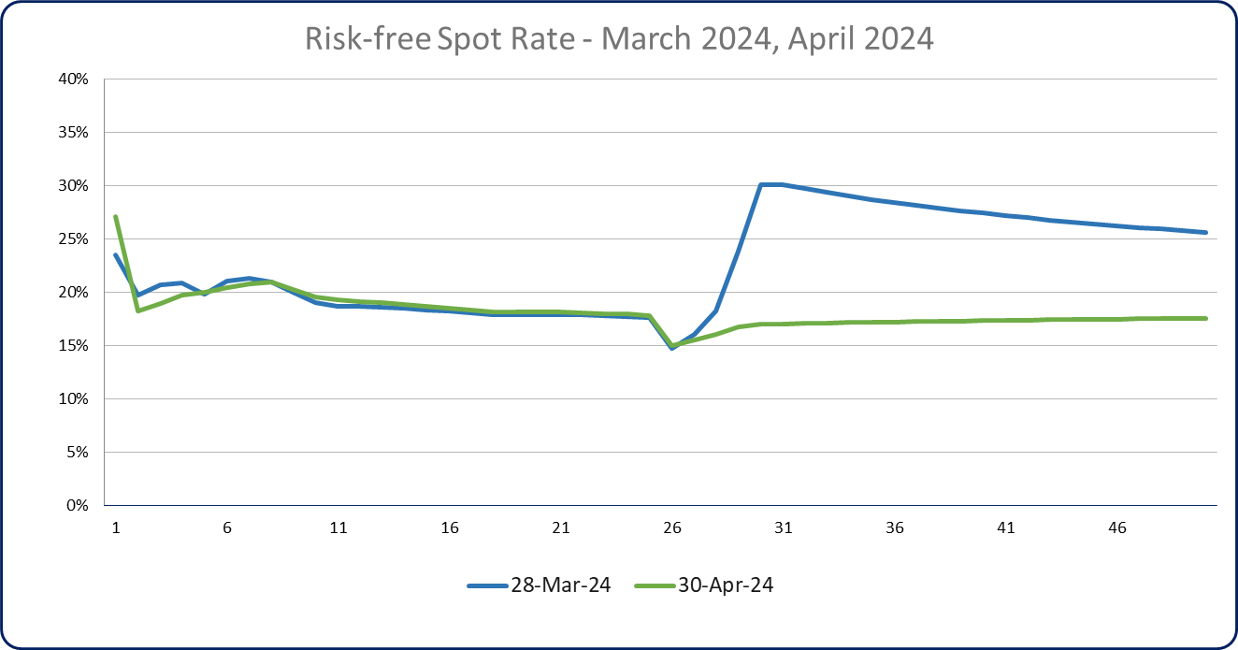

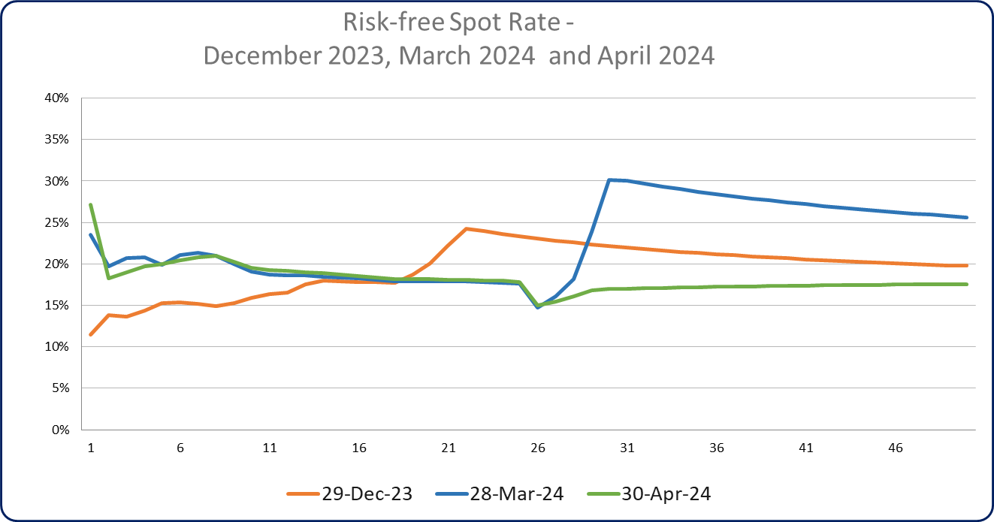

This is the weighted average based on allocated amount
Liquidity according to market trades have been determined by the provider of the data
Liquidity according to market trades have been determined by the provider of the data

